|  |  |  |  |  |
| --- | --- | --- | --- | --- |
|  |  | | |  |
|  | | |
|  | | |
|  | | | |
|  | **Huawei Server Ansible roles**  **1.0**  **User Guide** | |  |
|  | |
| **Issue** | **01** |
| **Date** | **2018-09-29** |
|  | |

Contents

1 About This Document 1

2 Overview 3

3 Installing and Uninstalling the Ansible roles 4

3.1 Installing the Ansible roles 4

3.2 Uninstalling the Ansible roles 5

4 Configuring the Ansible roles 6

5 Adding Managed Servers 7

6 Using the Ansible roles 9

6.1 Querying Driver and Firmware Versions 9

6.2 Upgrading Drivers and In-Band Firmware 11

6.3 Upgrading the BMC 13

6.4 Upgrading the BIOS 14

6.5 Automatic Upgrade 15

6.6 Restarting the OS 16

6.7 Uninstalling the HSU 17

# About This Document

Purpose

This document describes how to install and uninstall the Huawei Server Ansible roles, how to query and upgrade Huawei server drivers and firmware, how to upgrade the BMC and BIOS, and how to perform an automatic upgrade.

Intended Audience

This document is intended for:

* Technical support engineers
* Maintenance engineers

Symbol Conventions

The symbols that may be found in this document are defined as follows.

| Symbol | Description |
| --- | --- |
|  | Indicates an imminently hazardous situation which, if not avoided, will result in death or serious injury. |
|  | Indicates a potentially hazardous situation which, if not avoided, could result in death or serious injury |
|  | Indicates a potentially hazardous situation which, if not avoided, may result in minor or moderate injury. |
|  | Indicates a potentially hazardous situation which, if not avoided, could result in equipment damage, data loss, performance deterioration, or unanticipated results.  NOTICE is used to address practices not related to personal injury. |
|  | Calls attention to important information, best practices, and tips.  NOTE is used to address information not related to personal injury, equipment damage, and environment deterioration. |

Change History

| Issue | Release Date | Description |
| --- | --- | --- |
| 01 | 2018-09-29 | This issue is the first official release. |

# Overview

The Ansible roles is a module running on the Ansible software.

You can implement the following functions by using this module:

* Querying driver and firmware versions
* Manual and automatic upgrade of drivers and in-band firmware
* Manual and automatic upgrade of the BMC and BIOS
* OS restart

The Ansible roles supports the following OSs on managed servers: Red Hat Enterprise Linux (RHEL) 6.9, 7.3, and 7.4.

The Ansible roles supports the following managed servers: 1288H V5, 2288H V5, 2288 V5, and 2488H V5.

# Installing and Uninstalling the Ansible roles

3.1 Installing the Ansible roles

3.2 Uninstalling the Ansible roles

## Installing the Ansible roles

Prerequisites

* Ansible 2.0.0 or later has been installed. For details, see the official Ansible website.
* You have obtained the Huawei Server Update Tool (HSU) software package.

Procedure

* Method 1:

Log in to the Ansible server as an administrator from an SSH tool, such as PuTTY.

Run the following command to install the Ansible roles:

**# ansible-galaxy install Huawei.server-upgrade**

[root@vps roles]# **ansible-galaxy install Huawei.server-upgrade**   
- downloading role 'server-upgrade', owned by Huawei   
- downloading role from https://github.com/Huawei/server-upgrade/archive/master.tar.gz   
- extracting Huawei.server-upgrade to /root/.ansible/roles/Huawei.server-upgrade   
- Huawei.server-upgrade(master) was installed successfully

Check the command output for the installation directory of the Ansible roles, which varies with the OS.

Upload the HSU software package to the **/etc/ansible/roles/Huawei.server-upgrade/files** directory on the Ansible server.

----End

* Method 2:

Download the Ansible roles package **Huawei.server-upgrade vX.X.tar** from the GitHub website.

Upload the package obtained in Step 1 to the **roles** directory in the Ansible installation directory and run the following command to decompress the package:

**# tar -xvf Huawei.server-upgrade vX.X.tar**

Upload the HSU software package to the **/etc/ansible/roles/Huawei.server-upgrade/files** directory on the Ansible server.

----End

## Uninstalling the Ansible roles

Log in to the Ansible server as an administrator from an SSH tool, such as PuTTY.

Run the following command to go to the **roles** directory in the Ansible installation directory. The following uses the default installation path of Ansible as an example.

**# cd /etc/ansible/roles**

Run the following commands to delete the **Huawei.server-upgrade** folder:

**# rm -rf Huawei.server-upgrade**

----End

# Configuring the Ansible roles

Configure the OS download source.

Log in to the Ansible server from an SSH tool, such as PuTTY.

Run the following command to go to the **defaults** directory:

**# cd /etc/ansible/roles/Huawei.server-upgrade**/**defaults**

Run the following command to open the **main.yml** file, and change the values of **baseurl** of CentOS, RHEL, and firmware to the correct URLs:

**# vi main.yml**

Changing baseurl



* By default, the value of **baseurl** is a URL on the [Huawei Online Upgrade Platform](https://houp.huawei.com/download/). If you cannot connect to the Internet, you can create a local image source and change **baseurl** to the path of the local image source.
* The values of **gpgcheck** are as follows:
* **yes** (default): Verification is performed on the downloaded RPM package.
* **0**: Verification is not performed on the downloaded RPM package.

----End

# Adding Managed Servers

Run the following command to go to the **examples** directory:

**# cd /etc/ansible/roles/Huawei.server-upgrade/examples**

Run the following command to add IP addresses of the managed servers (enter one IP address in each row): For example, to add the IP addresses 10.71.10.218 and 10.71.10.223, run the following command:

**# vim inventory**

[servers]   
10.71.10.218   
10.71.10.223

Run the following command to authenticate the managed server:

**# ssh-copy-id *user*@*host***

In this command, **user** indicates the user name for logging in to the managed server, and **host** indicates the IP address of the managed server. The following uses the server whose IP address is 10.71.10.218 as an example:

[root@ansible examples]# ssh-copy-id root@10.71.10.218   
/usr/bin/ssh-copy-id: INFO: Source of key(s) to be installed: "/root/.ssh/id_rsa.pub"   
The authenticity of host '10.71.10.218 (10.71.10.218)' can't be established.   
ECDSA key fingerprint is SHA256:fJT1L/6HQZcDGmjsoiyF6U54kqS/3jnJnka658HqQpg.   
ECDSA key fingerprint is MD5:b1:d0:35:a7:8e:f6:2f:0f:5d:dc:d1:1d:ec:c0:d5:76.   
Are you sure you want to continue connecting (yes/no)?

Enter **yes**.

/usr/bin/ssh-copy-id: INFO: attempting to log in with the new key(s), to filter out any that are already installed   
/usr/bin/ssh-copy-id: INFO: 1 key(s) remain to be installed -- if you are prompted now it is to install the new keys   
root@10.71.10.218's password:

Enter the user name and password.

Number of key(s) added: 1   
   
Now try logging into the machine, with: "ssh 'root@10.71.10.218'"   
and check to make sure that only the key(s) you wanted were added.

----End

# Using the Ansible roles

If multiple servers are added and authenticated in 5 Adding Managed Servers, the following operations are performed on all these servers.

6.1 Querying Driver and Firmware Versions

6.2 Upgrading Drivers and In-Band Firmware

6.3 Upgrading the BMC

6.4 Upgrading the BIOS

6.5 Automatic Upgrade

6.6 Restarting the OS

6.7 Uninstalling the HSU

## Querying Driver and Firmware Versions

Run the following command to go to the **examples** directory:

**# cd /etc/ansible/roles/Huawei.server-upgrade/examples**

Run the following command to query driver and firmware versions:

**# ansible-playbook -i inventory upgrade-list.yml**

PLAY [servers]*******************************************************************************************************************   
   
TASK [Gathering Facts] **********************************************************************************************************   
ok: [10.71.10.218]   
   
TASK [Huawei.server-upgrade : Ensure HSU directory exists] *********************************************************************   
ok: [10.71.10.218]   
   
TASK [Huawei.server-upgrade : Ensure tar tool installed] ***********************************************************************   
ok: [10.71.10.218]   
   
TASK [Huawei.server-upgrade : Deploy Huawei Server Upgrade Tool] ***************************************************************   
changed: [10.71.10.218]   
   
TASK [Huawei.server-upgrade : include_tasks] ***********************************************************************************   
included: /etc/ansible/roles/Huawei.server-upgrade/tasks/upgrade-list.yml for 10.71.10.218   
   
TASK [Huawei.server-upgrade : Add Huawei Houp driver repo] *********************************************************************   
changed: [10.71.10.218]   
   
TASK [Huawei.server-upgrade : Add Huawei Houp firmware repo] *******************************************************************   
changed: [10.71.10.218]   
   
TASK [Huawei.server-upgrade : Gather Huawei Server upgrade list] ***************************************************************   
ok: [10.71.10.218]   
   
TASK [Huawei.server-upgrade : Display Huawei Server upgrade list] **************************************************************   
ok: [10.71.10.218] => {   
 "failed_when_result": false,   
 "msg": {   
 "Drv-i40e": {   
 "type": "net",   
 "v-max": "2.4.6",   
 "v-use": "2.4.6",   
 "vlist": [   
 "2.4.6"   
 ]   
 },   
 "Drv-megaraid_sas@0000:1c:00.0": {   
 "type": "raid",   
 "v-max": "07.703.09.00",   
 "v-use": "06.811.02.00-rh1",   
 "vlist": [   
 "07.703.09.00"   
 ]   
 },   
 "FW-AL14SEB030N@68R0A15LF4VD": {   
 "type": "disk",   
 "v-max": "0805",   
 "v-use": "0805",   
 "vlist": [   
 "0805"   
 ]   
 },   
 "FW-Bios": {   
 "type": "bios",   
 "v-max": "8.82",   
 "v-use": "8.82",   
 "vlist": [   
 "8.82"   
 ]   
 },   
 "FW-iBMC": {   
 "type": "ibmc",   
 "v-max": "3.11",   
 "v-use": "3.11",   
 "vlist": [   
 "3.11"   
 ]   
 }   
 }   
}   
PLAY RECAP **********************************************************************************************************************   
10.71.10.218 : ok=9 changed=1 unreachable=0 failed=0

Table 6-1 describes the parameters.

Parameter description

| Parameter | Description |
| --- | --- |
| Drv-xxx | Driver name |
| @0000:1c:00.0 | Bus number:Device number:Function number |
| FW-xxx | Firmware name |
| type | Firmware type |
| v-max | Latest version in the upgrade list |
| v-use | Current version |
| v-list | Upgrade list |

----End

## Upgrading Drivers and In-Band Firmware

Preparations

Before the upgrade, check the compatibility of the drivers and firmware of the target versions to prevent incompatibility issues. For details, see *FusionServer iDriver V100R001C00 Driver Version Mapping Vxxx* on [Support > Product Support > Carrier IT > Server > FusionServer > Rack Server > FusionServer iDriver](http://support.huawei.com/carrier/productNewOffering?col=product&allProduct=true&path=PBI1-21430725/PBI1-21430756/PBI1-21781511/PBI1-21783579/PBI1-21588909&resTab=PD).

Procedure

Run the following command to go to the **examples** directory:

**# cd /etc/ansible/roles/Huawei.server-upgrade/examples**

Run the following command and enter the names and target versions of the drivers and in-band firmware in the **inband-upgrade.yml** file based on the query result in 6.1 Querying Driver and Firmware Versions:

**# vim inband-upgrade.yml**

Specifying the names and target versions of the drivers and in-band firmware to be upgraded

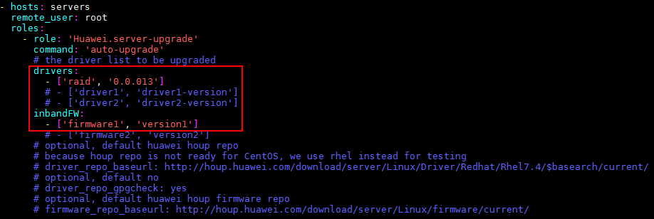

Run the following command to upgrade the drivers and in-band firmware:

**# ansible-playbook -i inventory inband-upgrade.yml**

Upgrading drivers and in-band firmware

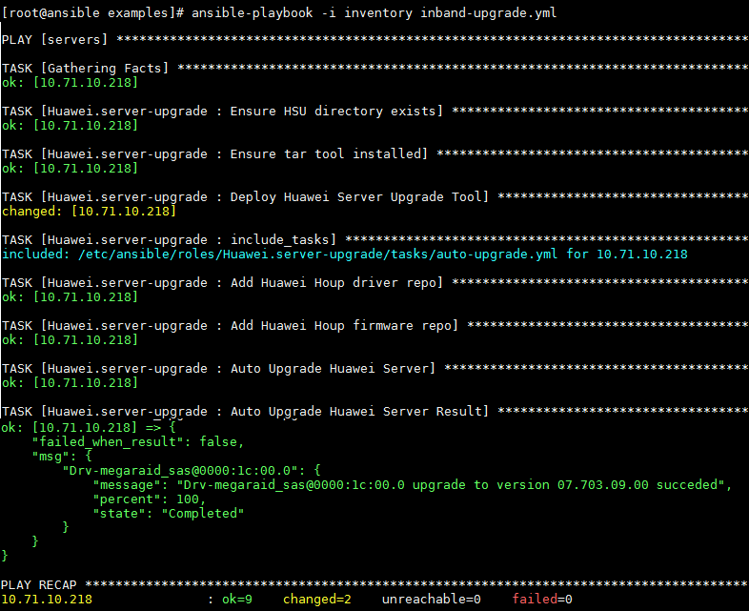

Check the **Auto upgrade Huawei Server Result**. If the result is "ok", the upgrade is successful. If the result is "failed", the upgrade fails. You can check the **message** row for failure causes.

----End

## Upgrading the BMC

Run the following command to go to the **examples** directory:

**# cd /etc/ansible/roles/Huawei.server-upgrade/examples**

Run the following command and enter BMC upgrade information in the **bmc-upgrade.yml** file based on the query result in 6.1 Querying Driver and Firmware Versions. Then save the settings and exit.

**# vim bmc-upgrade.yml**

Modifying BMC information



Run the following command in **examples** directory to upgrade the BMC:

**# ansible-playbook -i inventory bmc-upgrade.yml**

Upgrading the BMC

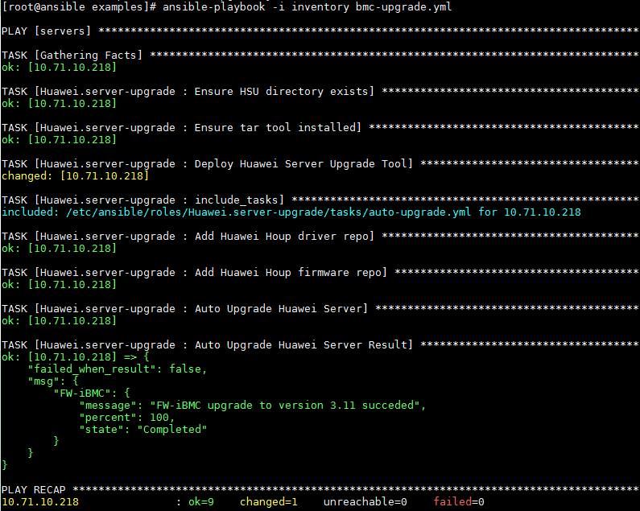

----End

## Upgrading the BIOS

Run the following command to go to the **examples** directory:

**# cd /etc/ansible/roles/Huawei.server-upgrade/examples**

Run the following command and enter BIOS upgrade information in the **bios-upgrade.yml** file based on the query result in 6.1 Querying Driver and Firmware Versions. Then save the settings and exit.

**# vim bios-upgrade.yml**

Modifying BIOS information



Run the following command in **examples** directory to upgrade the BIOS:

**# ansible-playbook -i inventory bios-upgrade.yml**

Upgrading the BIOS

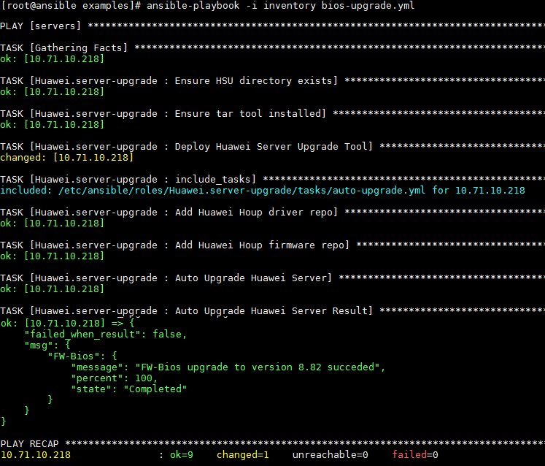

----End

## Automatic Upgrade

In automatic upgrade, a driver is automatically upgraded when the latest version in the upgrade package library is later than the current version, and the in-band firmware is automatically upgraded when the version in the library is inconsistent with the current version.

Run the following command to go to the **examples** directory:

**# cd /etc/ansible/roles/Huawei.server-upgrade/examples**

Run the following command in the **examples** directory:

**# ansible-playbook -i inventory auto-upgrade.yml**

Automatic upgrade

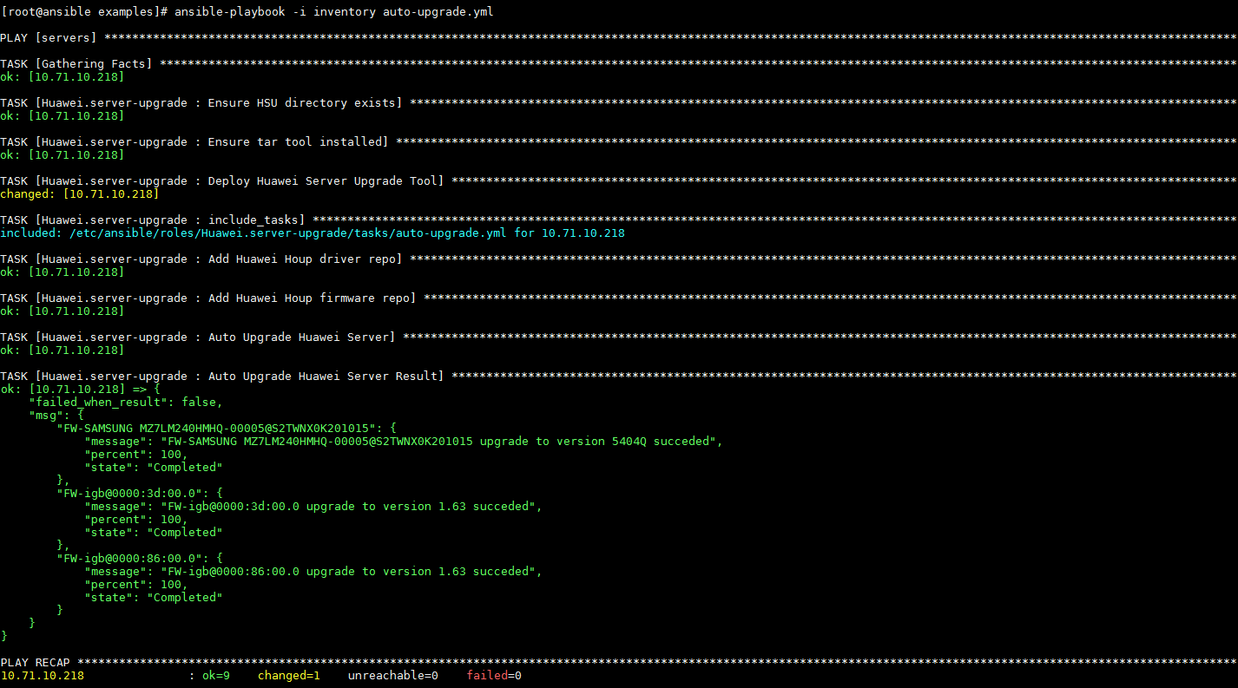

----End

## Restarting the OS

Run the following command to go to the **examples** directory:

**# cd /etc/ansible/roles/Huawei.server-upgrade/examples**

Run the following command in the **examples** directory to restart the OS:

**# ansible-playbook -i inventory restart.yml**

Restarting the OS

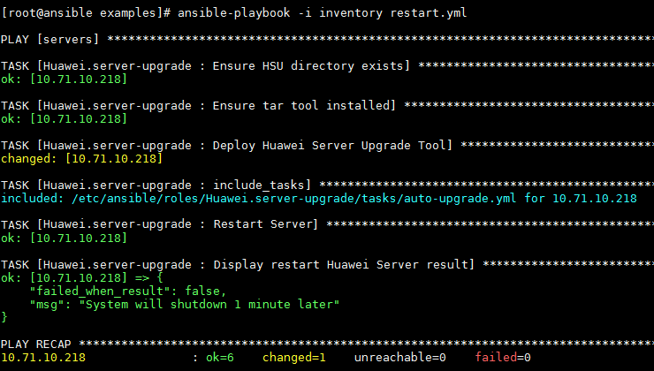

----End

## Uninstalling the HSU

Run the following command to go to the **examples** directory:

**# cd /etc/ansible/roles/Huawei.server-upgrade/examples**

Run the following command in the **examples** directory to uninstall the HSU:

**# ansible-playbook -i inventory remove-hsu.yml**

Uninstalling the HSU

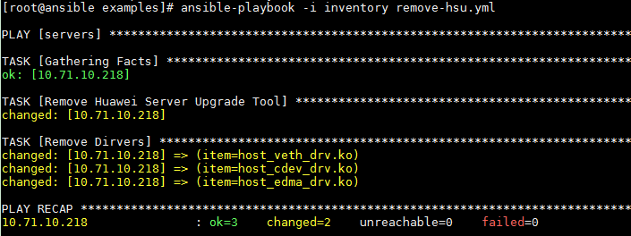

----End